'Stop the dead men stealing'

Department of Land Resource Management scientist Glenn Wightman was recording Malngin biocultural knowledge with a deceased Malngin elder (whose name cannot be used for cultural reasons), in 2007. Glenn asked the old man what the Malngin name was for a bush cucumber, he thought for little while, and then said 'All the dead men bin take it away, them dead men bin steal it'.
That old man could not remember the Malngin name of the bush cucumber and was referring to the fact that the only people who knew the name were actually deceased. The publication of a book detailing the biocultural knowledge of Bilinarra, Gurindji and Malngin people has stopped the dead men stealing this ancient and wonderfully detailed plant and animal wisdom.
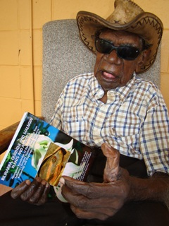
The book is called 'Bilinarra, Gurindji and Malngin plants and animals'. It contains names, uses and other knowledge of almost 500 species from the southern parts of Judbarra / Gregory National Park and the Victoria River area of semi-tropical north Australia. The book was prepared by 26 Aboriginal knowledge custodians with assistance from eight linguists and biologists over a 20 year period.
The book was a collaboration between Bilinarra, Gurindji and Malngin elders, the Northern Territory Government, Mimi Aboriginal Art & Craft and Diwurruwurru-jaru Aboriginal Corporation. It can be purchased from Mimi Aboriginal Art & Craft, phone 08 8971 0036, email community@mimiarts.com

