Aboriginal Ranger Grants Program Guidelines: Round Eight – 2024-25

  - - Land and Sea Management Fund
- Ichthys LNG Conservation Management Offset

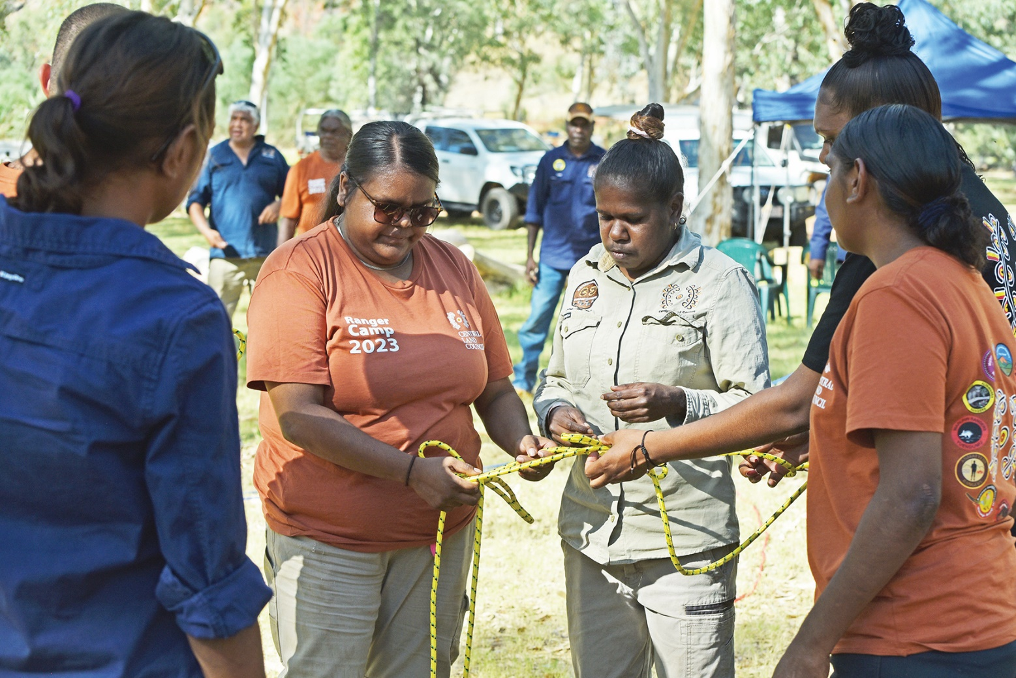
Document title | Aboriginal Ranger Grants Program Guidelines: Round Eight – 2024-25
Contact details | Department of Environment, Parks and Water Security
Approved by | Alaric Fisher, Executive Director, Flora and Fauna
Date approved | 02 April 2024
Document review | Annually
TRM number | BD2024/0014-0003~0003

Version | Date | Author | Changes made
1.0 | 3rd July 2023 | Anna Belford | First version – Round Seven
1.1 | 2nd April 2024 | Anna Belford | Updated for Round Eight

Acronyms | Full form
ABN | Australian Business Number
ALMAG | Aboriginal Land Management Advisory Group
ARGP | Aboriginal Ranger Grant Program
DEPWS | Department of Environment, Parks and Water Security
GST | Goods and Services Tax
Ichthys LNG | Refers to INPEX-operated Ichthys LNG, a joint venture between INPEX group companies, TotalEnergies, and the Australian subsidiaries of CPC Corporation Taiwan, Tokyo Gas, Osaka Gas, Kansai Electric Power, JERA and Toho Gas. INPEX Operations Australia Pty Ltd acts as the Operator of the Project.
Ichthys CMO | Ichthys LNG Conservation Management Offset
ILSC | Indigenous Land and Sea Corporation
IPA | Indigenous Protected Area
LNG | Liquefied Natural Gas
LSMF | Land and Sea Management Fund
MERI | Monitoring, Evaluation, Reporting and Improvement
MNES | Matters of National Environmental Significance
NIAA | National Indigenous Australians Agency
NT | Northern Territory
S19 ILUA, Section 19 agreement | An agreement under section 19 of the Aboriginal Land Rights (Northern Territory) Act 1976 (Commonwealth) (Land Rights Act).
TNRM | Territory Natural Resource Management

Cover photo: Kitana Shaw (Aputula Rangers) and Helma Bernard (Murnkurrumurnkurru Rangers at Daguragu) - Leadership and Team Building at the Central Land Council Ranger Camp.
© Central Land Council

Table of Contents
Table of Contents 3
Background 4
Overview of funding available in Round Seven 4
Scope of funding 5
Grant process 7
Eligibility for funding 8
Other important considerations 9
Assessment 11
Terms and Conditions 12
Further Information 12

Background

Aboriginal land comprises approximately 50 per cent of the Northern Territory (NT) land area and 85 per cent of the coastline. Aboriginal Ranger programs emerged during the 1990s as Aboriginal land owners formalised their management of country, and developed aligned environmental enterprises.
Aboriginal ranger programs in the NT deliver long-term environmental, economic and social development outcomes, and are internationally recognised as best practice natural and cultural resource management models. Despite this, many Aboriginal ranger groups are significantly under-resourced to manage their land and sea country.
The NT Government Protecting Country, Creating Jobs initiative supports Aboriginal rangers through the Aboriginal Ranger Grants Program (ARGP), which commenced in 2017-2018, and is currently funded to 2024-2025. The ARGP also delivers the Ichthys LNG Coastal Management Offset (Ichthys CMO), which is funded until 2043-2044. More information about Ichthys LNG offsets can be found in the Coastal Offset Strategy.
Advice about Aboriginal needs and aspirations for land and sea management on Aboriginal land, and the development and effective implementation of the grants program, is provided by the Aboriginal Land Management Advisory Group (ALMAG). ALMAG is comprised of professionals with significant knowledge and expertise in Aboriginal land and sea management throughout the NT, and Aboriginal cultural knowledge is respected and elevated in and through the group. ALMAG engagement with the ARGP ensures the program remains highly relevant and adaptable, supporting Aboriginal Rangers to manage their land and sea country for conservation, cultural and social outcomes.

Overview of funding available in Round Eight
 | Land and sea management fund
Available funding | $1.1 million
Type of funding  (refer to section  4 for more detail) | Project and activity based work. May include cultural and social outcomes, in addition to environmental outcomes.
Time frames | Up to 18 month projects – must be completed by December 2025.
Funding limit | Single year project up to $200K, 18 months project up to $300K.
Applications | A separate application must be submitted for each project for which funding is sought.
 | Ranger groups may submit more than one application for funding, and multiple ranger groups may submit a joint application to fund shared items and projects.

Ichthys coastal management offset
Available funding | $1.2 million
Type of funding  (refer to section  4 for more detail) | Project and activity based work. May include cultural and social outcomes, in addition to environmental outcomes. | Purchase of capital items, equipment and infrastructure
Time frames | Projects from one to five years. | One off.
Funding limit | Up to $200K per year. | $250K, however exceptional* projects of up to $500K will be considered.
Applications | A separate application must be submitted for each project for which funding is sought. | Multiple capital items, equipment or infrastructure can be included on the same application but combined value must be within limit.
 | Both Project and capital funding can be applied for on the same application, which will be assessed as a single entity.
Outcomes and targets must link directly or indirectly to: | Mammals: Dugong, Dolphins (multiple species), Whales (multiple species)  Reptiles: Marine Turtles (six species)  Sharks: Freshwater and Green Sawfish, Whale Shark  Birds: Great Knot, Greater Sand Plover, Lesser Sand Plover  Full list of eligible species at Appendix A of the Coastal Offset Strategy.  Marine Habitats: Foraging and nesting habitat (such as Seagrass, Reefs, Beaches)  Threat Management: Marine debris, feral animal control, climate change, light and noise pollution, Indigenous take, vessel disturbance, fisheries bycatch and others.  See also Recovery Plan for Marine Turtles, and Marine Debris Threat Abatement Plan.
*Projects may be considered exceptional where they have a regional impact, address a critical gap that cannot be addressed by other funding sources, or be particularly innovative or progressive.
There are several other NT Government grants and financial incentives that your organisation may be eligible for, such as the Aboriginal Responsive Skilling Grant, Aboriginal Workforce Grant, Aboriginal Tourism Grant and Aboriginal Business Development Program.

Scope of funding

Applications must be responsive to an identified need or demand, and deliver clear land and sea management, conservation, and cultural outcomes. Applications will not be considered if activities are considered ‘business as usual’ and already funded through existing sources (such as NIAA or ILSC core funding).
Examples of grants that could be funded include, but are not limited to those described below:

Capital, equipment or infrastructure components of
Ichthys coastal management offset grants
Vehicles – for launching boats – 4WD or ATV.
Boats – vessels, boat trailers, moorings, motors, navigation and safety equipment.
Light equipment - PPE and safety equipment, survey and monitoring equipment.
Infrastructure to support ranger activities– ranger base, remote base, or ablution block.
Improvements to existing infrastructure - storage, power and water system upgrades.
Management systems – Communications, asset management and information management.

Your application must demonstrate links between the capital items and the conservation of species and habitat as listed above.
Brief summaries of previous Ichthys CMO grants with capital components can be found under ‘Previous Recipients’ at Aboriginal Ranger Grants Program | Department of Environment, Parks and Water Security
Land and sea management fund, and project components of
Ichthys coastal management offset grants
On-ground activities – weed, fire and feral management for environmental and cultural outcomes such as pig control and management to reduce turtle egg predation; marine debris removal and management programs; management of threatened and iconic species and their habitat; sacred and cultural site management.
Investment in people –Training and skill development in governance, communication, knowledge recording and transfer, the use of technology and equipment, compliance and enforcement, and other practices to support Aboriginal management of land and sea country.
Growing the sector – Development of fee-for-service activities; carbon abatement projects including blue carbon; research and monitoring; sustainable use programs.
Monitoring and evaluation (M and E) - Development of best practice M and E strategies, techniques and tools, to better quantify the environmental and cultural benefits of Aboriginal land and sea management programs, especially where these may support business cases to secure or continue funding; direct or indirect monitoring and management for dugongs, turtles or cetaceans
Planning - Development of plans of management for Aboriginal land and sea country, such as Healthy Country Plans, Feral animal and Weed management Plans, development of regional management plans for terrestrial and marine Matters of National Environmental Significance (MNES).
Improvement of local governance arrangements.
Innovation - Programs based on Aboriginal cultural and ecological knowledge; use of new technologies or application of older technology in a new way.
Brief summaries of all successful LSMF and Ichthys CMO Grants from Rounds 1 to 7 can be found under ‘Previous Recipients’ at Aboriginal Ranger Grants Program | Department of Environment, Parks and Water Security

Grant process

The process for assessment, approval and reporting on ARGP funding is summarised in this flowchart:
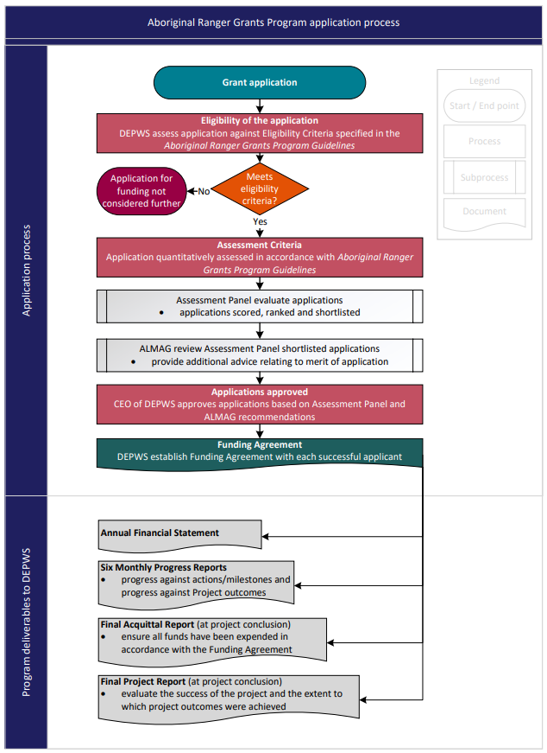

Eligibility for funding

5.1 Who can apply?
The Aboriginal Ranger Grants are open to Aboriginal organisations, including Ranger Groups, Land Councils and Aboriginal-controlled incorporated associations that are registered or incorporated within the NT, and which have a clearly identified role in management and conservation on Aboriginal land and seas.
To be eligible, your organisation must be up to date with all reporting and acquittals for all previous
ARGP grants.
  - How to apply
Applications must be submitted using the NT Government’s GrantsNT Administration with all necessary supporting documentation. The application process is open from 8am Monday 6th May until 5pm Friday 31st May 2024. Late applications will not be accepted and no extensions will be granted.
If you are a first time user you will need to register to create an account and setup an organisation profile. The GrantsNT website has a comprehensive help section to guide you. Starting with the GrantsNT Introduction section is highly recommended as it will give you a good overview of the system.
If you have used GrantsNT previously, please review and update all organisation and contact details before you apply.
  - Completeness of application
Your application must meet the eligibility criteria to be further considered
- Organisational and contact details must be complete and current.
- All application questions must be completed.
- Budget template must be completed and attached.
- Milestone template must be completed and attached.
- You must attach quotes for any items over $10 000 during the application process.
- If applicable, you must attach letters of support.
- If applying for Ichthys CMO Grants, your proposal must result in benefits to eligible species or their habitat (refer to Section 2, above).
- You must demonstrate that you hold or are able to acquire any permissions necessary to undertake the proposed project (see Section 6.3 below).
- You must hold appropriate insurance covering legal liability (including liability assumed under contract). Please refer to Aboriginal Ranger Grants Program | Department of Environment, Parks and Water Security for full Terms and Conditions.

Other important considerations

6.1 Promoting gender equity
Applications that promote gender equity in caring for Country projects will be highly regarded. You will be prompted to describe how your project promotes equitable access to:
• respectful workplaces
• resources and training
• flexible work schedules
• representation in decision making
or explain why it does not, or if this is not applicable.
For ideas on how to support women caring for Country specifically, please refer to the best practice principles compiled by the Strong Women for Healthy Country Network: www.mimal.org.au/strong-women-healthy-country.
6.2 Funding for staff, contractors, or consultants.
Applications may include personnel expenses for rangers and support staff only where they are not already employed through core NIAA or ILSC funding AND they are essential to delivering project outcomes AND this is fully justified in the application. The ARGP grants are not intended to pay the salary of rangers as an outcome by itself, or be used to establish new ranger groups.
To the maximum possible extent, any personnel expenses should be for Aboriginal people.
Funding for consultants or contractors to deliver specific components within a project will be considered only where this is essential to delivering project outcomes AND this is fully justified in the application.
The NT Government endorses a policy of “Buy Local” for all NT Government funded items and programs including programs funded through NT Government grants. Goods and services should be sourced from Aboriginal owned businesses wherever possible, and suppliers from outside the NT can only be considered where there is no Territory supplier.
Please refer to the NTG Aboriginal Procurement Policy and the NTG Buy Local Plan for further information.
  - Permits and agreements
When completing your application, please ensure you have considered if any permits and agreements will be necessary to complete your proposed project. You will be prompted to provide your own assessment of what is required and to demonstrate that you have, or will be able to gain, these permissions. This may include:
- Section 19 agreements - Land Use agreements to carry out commercial or construction activities on Aboriginal land associated with a project to be funded under the grants program
Leasing and licensing Aboriginal land - Central Land Council (clc.org.au)
Section 19 Land Use Agreements | Northern Land Council (nlc.org.au)
Tiwi Land Council
Development Planning » Anindilyakwa Land Council

- Land Council permits for access, research, and community and ecological projects

Permits - Central Land Council (clc.org.au)
Permits | Northern Land Council (nlc.org.au)
Land Access Permits » Anindilyakwa Land Council
Tiwi Land Council
- Animal Ethics – Required when projects involve the use of animals in research or teaching.

Animal ethics | Charles Darwin University (cdu.edu.au)

- Animal Welfare - Groups that undertake animal research (i.e. have project that require Animal Ethics approval) also need to register under the Animal Protection Act

Permits to work in research program | NT.GOV.AU
- Wildlife Permits - Take and Interfere Permit is the key permit for most projects involving native animals and plants, and requires proof of land holder’s consent

Wildlife permits | NT.GOV.AU
  - Joint applications and partnerships
Organisations are encouraged to submit joint applications that bring together a number of eligible parties to achieve regional outcomes.
Applications that leverage support from partner organisations are also encouraged, particularly those which are improved by co-funding and in-kind support, or would not be possible without.
  - Management Plans and Traditional Owner and community priorities.
Your proposal should be driven by the priorities of Traditional Owners and provision of evidence supporting this is encouraged.
Your project should have outcomes that are linked to priorities identified in relevant local and regional Plans of Management where these exist, including:
- Healthy Country Plans
- IPA Plans
- MERI Plans
- Joint Management Plans
- The Northern Territory Natural Resource Management Plan 2021-2026
- Threatened Species Recovery Plans
- Threat Abatement Plans
Preference will be given to eligible applications from groups and in regions that have been under-represented in previous ARGP rounds.

Assessment

Each eligible application will be assessed against the following criteria:
OUTCOMES and RELEVANCE: Meets the ARGP objectives and general requirements. 20%
- Application is responsive to identified need or demand.
- Will deliver clear land and sea country management, conservation and cultural outcomes.
- Application includes clearly defined measures of progress and achievement.
VIABILITY and CAPABILITY: Effective planning and use of resources; ability to deliver. 35%
- Project is realistic, suitable and achievable – demonstrates good planning and effective use of resources.
- Budget is viable and realistic; includes breakdown of expenditure, co-contributions and in-kind contributions, demonstrates value for money, goods and services sourced from Aboriginal owned businesses and local suppliers (Section 6.2).
- Project is improved or made viable by leveraging additional funds or in-kind support (Section 6.4).
- Ranger group or organisation has limited ability to fund project without this grant.
- Any staffing and consultant costs are properly justified by the applicant.
- Ranger group or organisation has the appropriate skills and knowledge to deliver the activity on time, and within budget.
- Increases the ability of Aboriginal people and organisations to undertake land and sea management.
- Time constraints for LSMF will be met (completion by Dec 31st 2025).
IMPACT: Long term benefit to Country, community and conservation. 35%
- Promotes gender equity (Section 6.1).
- Delivers employment, economic, social and cultural benefits to Aboriginal people.
- Strengthens community and regional engagement in conservation and cultural activities.
- Outcomes are linked to priorities identified by TOs and in existing plans of management (Section 6.5).
- Assists Aboriginal groups and governing bodies and the constituent communities they represent to become stronger and self-sustaining.
- The outcomes have long-term benefits that will persist beyond the life of the Grants Program.
QUALITY: Merit and innovation. 10%
- Demonstrates a collaborative and regional approach (Section 6.4).
- Increases the scope and extent of Traditional Owner driven Aboriginal land and sea management through innovative approaches.
- Employs or develops best practice methodologies.

Terms and Conditions

Full terms and conditions are available at Aboriginal Ranger Grants Program | Department of Environment, Parks and Water Security under the section ‘Terms and Conditions’.

Further Information

For further information please contact:
Aboriginal Ranger Grants Program
Department of Environment, Parks and Water Security
PO Box 496, Palmerston NT 0831
e: RangerGrants.DEPWS@nt.gov.au
p: 0498 046 864

