Fact sheet 1: The environmental regulatory reform program

Caution: Archived content
This content was created to serve a specific purpose at a particular period/time.
It may contain references to policy positions, approaches, documents or other information that has been superseded.
An introduction to the new environment protection legislation

Background
The Northern Territory Government (Territory Government) is reviewing and reforming the current environmental regulatory system. Reforms are critical to achieving a robust regulatory system that the community will trust while encouraging industry investment and economic growth.
A single piece of legislation is being developed to implement a reformed environmental management regulatory framework – the Environment Protection Act (the Act).
Development of the Act, and the reform program, has been separated into two stages.
The first stage will reform the environmental impact assessment process and introduce a new environmental approval that may be granted by the Minister for Environment and Natural Resources (the Minister) at the completion of the assessment process.
The second stage will reform how the Northern Territory (the Territory) manages its wastes, pollution, clearing of native vegetation and the environmental impacts of mining activities.

Reform goal, objectives and principles
The Territory Government identified an overarching goal, objectives and principles to inform the environmental regulatory reform program. These are shown in the figure below.
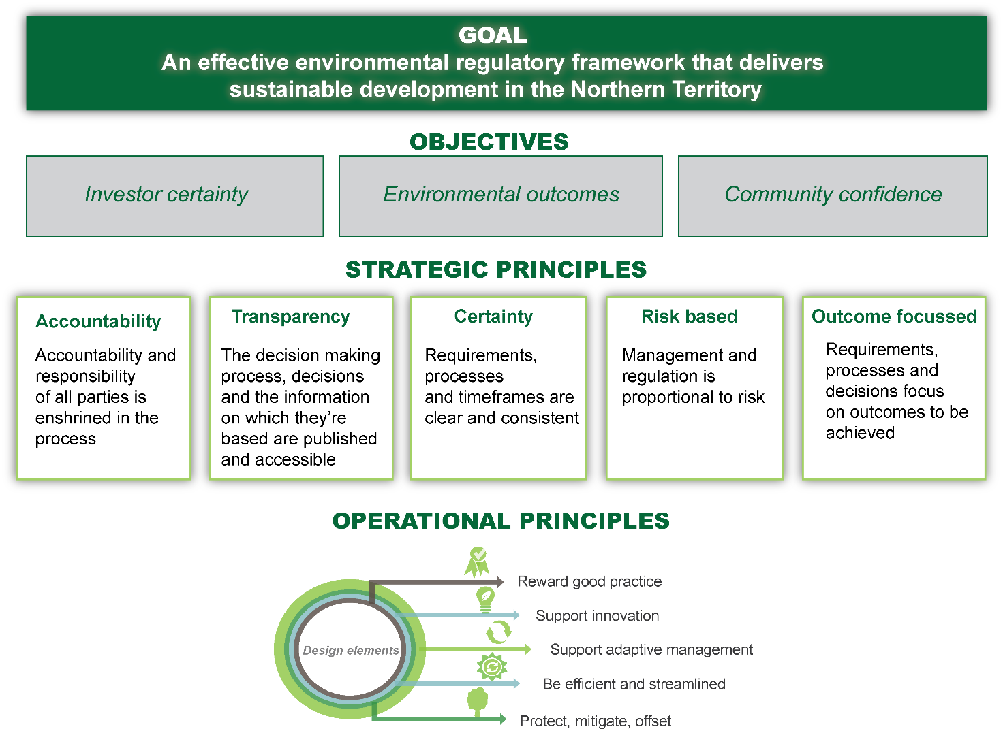

Environment Protection Bill
The Environment Protection Bill 2019 (the Bill) has been prepared to deliver an improved environmental impact assessment and approval system for the Territory.
The Bill:
- establishes requirements for an improved environmental impact assessment system
- introduces a new environmental approval granted by the Minister at the completion of the assessment process, or refusal where there is likely to be unacceptable impact
- contains a range of tools designed to promote compliance and enable enforcement.
The Bill will replace the existing Environmental Assessment Act 1982. Regulations that describe the environmental impact assessment process will be developed to support the Bill. These Regulations will replace the Environmental Assessment Administrative Procedures 1984.

Objects of the Bill
The objects set out in the Bill are:
- to protect the environment of the Territory
- to promote ecologically sustainable development so that the wellbeing of the people of the Territory is maintained or improved without adverse impact on the environment of the Territory
- to recognise the role of environmental impact assessment and environmental approval in promoting the protection and management of the environment of the Territory
- to provide for broad community involvement during the process of environmental assessment and environmental approval
- to recognise the role that Aboriginal peoples have as stewards of their country as conferred under their traditions and recognised in law, and the importance of participation by Aboriginal peoples and communities in environmental decision-making processes.
To support these objects, the Bill establishes principles of ecologically sustainable development and sets out an environmental decision-making hierarchy to guide decision-makers and ensure the objects of the Bill are met.

Improving the environmental impact assessment process
The Bill defines the purpose of the environmental impact assessment process within the Territory.
Key elements of the proposed environmental impact assessment system include:
- establishing pathways for referral of proposed actions (or projects) to the Northern Territory Environment Protection Authority (NT EPA)
- placing responsibility for referring a proposed project to the NT EPA with the proponent
- increasing public scrutiny and opportunities for participation within the process
- supporting the environmental impact assessment process with defined offences and regulatory powers.
Environmental impact assessment processes will be included in the Regulations. These processes will establish different tiers for assessment to provide a more streamlined and risk-based approach to assessment, and establish processes for conducting strategic assessments. It will also introduce timeframes for decision making and public consultation processes.
See the ‘Environment Protection Regulations’ factsheet for more information on the proposed Regulations.

Introducing an environmental approval
The Bill introduces an environmental approval to be granted (or refused) at the conclusion of the environmental impact assessment process. All proposed projects requiring an environmental approval will be assessed under the new environmental impact assessment process.
The NT EPA will oversee the environmental impact assessment process and prepare a draft environmental approval (or a statement of unacceptable impact) for consideration by the Minister.
The Minister is responsible for granting or refusing the environmental approval. The Bill sets out matters to be considered by the Minister when making a decision on whether to issue an environmental approval for a proposed project.
The Bill provides for conditions to be placed on an environmental approval, including conditions relating to an environmental offset (if appropriate) and the payment of environmental bonds.
There are supporting provisions for varying, transferring, amending, suspending and revoking the environmental approval.

Establishing powers, offences and regulatory tools
The Bill establishes powers and enforcement tools and defines offences to support the environmental impact assessment and approval process.
Under the Bill, the NT EPA is provided with the powers to issue a:
- call-in notice requiring a proposed project which has the potential for significant impact to be referred
- stop work notice requiring work on-site to cease while a proposed project is being considered under the environmental impact assessment process.
Non-compliance with these notices is an offence under the Bill.
The Bill also introduces a suite of enforcement tools to support compliance against issued notices as well as defined offences and environmental approvals.
Northern Territory Government employees can be authorised as environmental officers to undertake compliance and enforcement activity under this Bill. A member of the Northern Territory Police Force is also an environmental officer for the purposes of the Bill to assist in monitoring compliance with the legislation and investigate alleged offences.
Enforcement tools include environmental officer directions, environment protection notices, enforceable undertakings, civil and criminal proceedings.

Environment protection levy, fees and funds
The Bill contains provisions that will allow the Minister to introduce an environment protection levy and establish environment protection funds to hold the proceeds from levies and other specific sources. The funds can be used in a number of ways that are specified in the Bill, including to improve the understanding of impacts on the environment through research, and to remediate or rehabilitate the environment.
The Bill contains provisions that will allow the government to introduce fees associated with the impact assessment and approval process in the future. There are currently no proposals to introduce fees.

Review or appeals
The Bill identifies who is able to seek a review of decisions made by the Minister, NT EPA, Chief Executive Officer of the Department of Environment and Natural Resources (the CEO) and environmental officers under the Bill.
The Bill provides for limited standing for judicial reviews. The following people can start proceedings in the Supreme Court and challenge the legal process that was followed in making a decision:
- a proponent of an action
- an applicant for a decision, such as a person who is requesting a review of a decision by the CEO to issue an environment protection notice or to refuse to issue an emergency authorisation
- a person directly affected by a decision
- a person who has made a genuine and valid submission during an environmental impact assessment and environmental approval.
The Bill also allows a person affected by a decision made by the CEO or an environmental officer, usually a person issued with a statutory notice such as an environment protection notice or authorised officer direction, to request the Northern Territory Civil and Administrative Tribunal (NTCAT) undertake a review of the decision.

Further reforms
The next stage of the reform program will see improvements to the way in which the Territory manages wastes, pollution, land clearing and the environmental impacts of mining activities.
The next stage of the reforms will include:
- a general environmental duty, placing responsibility on a person to ensure that their actions are undertaken in a manner that prevents and minimises impacts on the environment
- environmental protection policy provisions, allowing the development of environmental policy and standards required to support operational elements of the Act, e.g. the development of air quality standards
- a regulatory framework to manage environmental impacts, including discharges of waste water and other pollutants into the environment.
These reforms will result in amendments to the future Environment Protection Act, and the repeal and replacement of the Waste Management and Pollution Control Act 1998 and Litter Act 1972 and changes to the Mining Management Act 2001 and Water Act 1992.
Consultation on these reforms has started and will continue throughout 2019.

