This climate update provides information on predicted and actual water use for the 2021-22 water accounting year to date and provides an outlook to water resource management for the forthcoming water accouting year in the Katherine, Daly and Roper water resource systems.

Looking back

2021 Announced allocation outcomes
In May 2021 the Controller of Water Resources announced 100% allocations for water resources in the Katherine, Daly and Roper regions. This announcement was informed using modelling to predict river flows at specified locations at the end of the 2021 Dry season. Modelling considered reported water use provided by licence holders and climate data up to 31 March 2021. Modelling assumed 100% of licence entitlements and allocations to stock and domestic users would be taken during the 2021-22 water accounting year.
A comparison of modelled predicted river flows and measured flows at 1 November 2021 are shown in Figure 1 below.
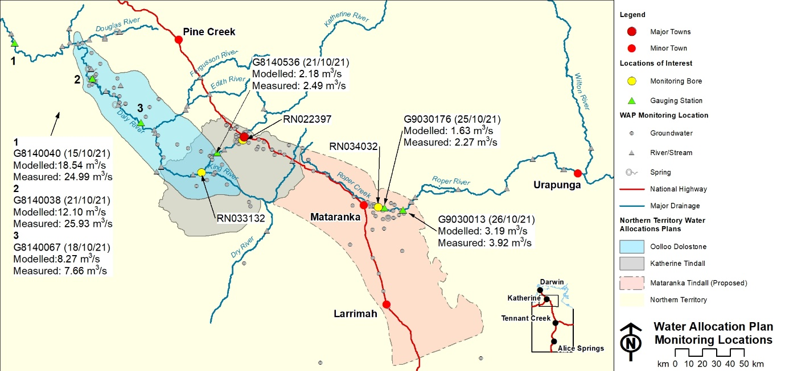
17.00
Figure 1 Comparison of modelled predicted river flows and measured flows at 1 November 2021
- At all locations measured river flows were more than the flows predicted in modelling.
- For the Katherine River and Daly River systems measured river flows at specified locations were more than the environmental flow criteria specified in the relevant water allocation plans.
- These results indicate that determining allocations based on predictive modelling is protective of environmental flows and relatively conservative.
- The difference between the measured and modelled environmental flows is most likely due to actual extractions during the water accounting year being significantly less than the maximum licensed entitlements used for the modelling scenarios.

2021 Reported water use
Licensed water extraction reported across the regions for the period 1 May to 15 December 2021 has remained steady in comparison for the same period the previous year as shown in Figure 2.
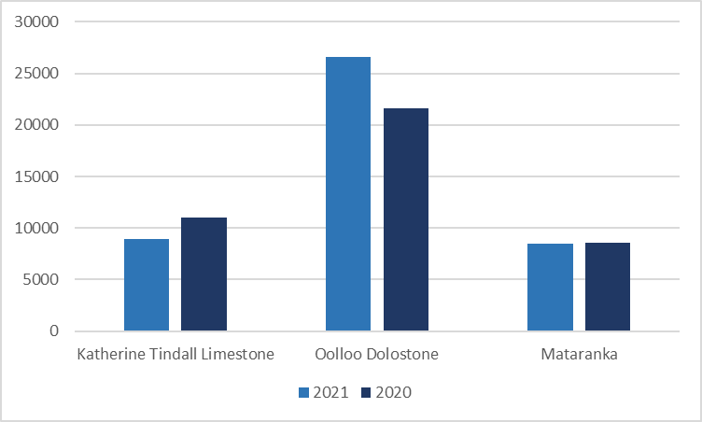
Figure 2 Comparison of reported water use
Reported licensed water extraction in the area of the Katherine Tindall Limestone Water Allocation Plan 2019-24 is currently 25 per cent of the total maximum volume that may be taken under a licence. This is a slight decrease from the 30 per cent reported in the previous period and likely a result of higher rainfalls compared with the previous year.
The area of the Oolloo Dolostone Water Allocation Plan 2019-29 reported water extraction at 28 per cent of the total maximum licensed volume up from 23 per cent for the same period the previous year. This increase is likely a reflection of increasing investment in water infrastructure across the region aligned with water extraction licence development plans.

Looking forward
Climate drivers and rainfall outlook information is sourced from the Bureau of Meteorology website. You can keep up to date with climate information by subscribing to the BoM website at:
http://www.bom.gov.au/climate/outlooks/#/overview/influences

Climate drivers
During the past month, a La Nina event has become established in the tropical Pacific and is expected to remain until late summer. A La Nina event typically leads to wetter than median conditions for eastern Australia, however has limited impact on Northern Australia.
A negative Indian Ocean Dipole (IOD) has come to an end and is now neutral. The neutral IOD has little influence on Australia’s climate.
Sea surface temperatures around tropical Australia are currently warmer than average and are expected to remain warmer than average throughout the summer months, contributing to increased rainfall and temperatures across northern Australia during that period.
The Madden-Julian Oscillation is not discussed here as it is periodic influence that acts as a climate booster, leading to enhanced rainfall under favourable conditions. As its presence in difficult to predict in the medium and long term it is not considered in this overview.

Rainfall outlook
The Bureau of Meteorology climate outlook for the 2021-22 northern Wet season are for average to slightly above median rainfalls across the Northern Territory.
Recent Rainfall
November saw wetter than average conditions across most of the NT, with the exception of the southern Top End which experienced below average rainfall for November.
BoM predictions are for slightly below median rainfall across the NT during December and January, with median to slightly above median rainfall conditions across the NT between February and April.
The three month outlook for January – March (Figure 1) is for median rainfall across most of the NT except for the eastern Top End/Gulf coast, while the three month outlook February – April (Figure 2) shows median to above median rainfall across most of the NT.
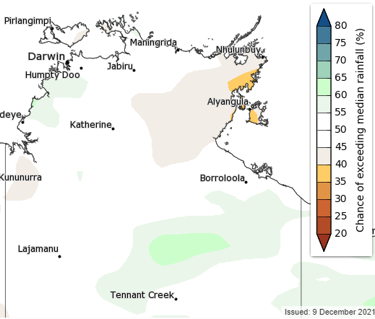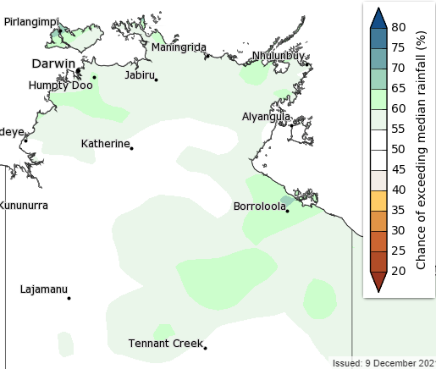
Figure 3. Chance of above median rainfall Jan – March Figure 4. Chance of above median rainfall March – April
(Source: http://www.bom.gov.au/climate/outlooks/#/rainfall/median/seasonal/0)
Figures 5 and 6 show the 75% and 50% probabilities of exceeding the displayed rainfall totals over the December to February period.
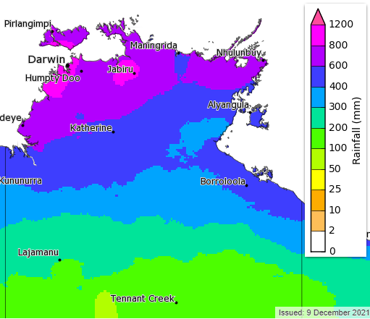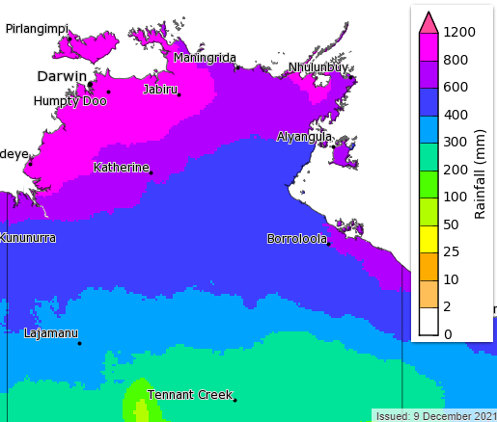
Figure 5. 75% rainfall exceeds (January – March) Figure 6. 50% chance rainfall exceeds (January – March)
(Source: http://www.bom.gov.au/climate/outlooks/#/rainfall/total/75/seasonal/0)

Groundwater levels
Routine monitoring of groundwater levels for the water allocation plan areas are nearing completion for the end of 2021 Dry season. The discrete measurements of the representative bores, as indicated in the three plots, show that groundwater levels have recharged to at least the same level as the previous year if not more so in some areas.
The 2020-21 Wet season of appears to have provided a greater recharge opportunity compared to the previous three Wet season periods.
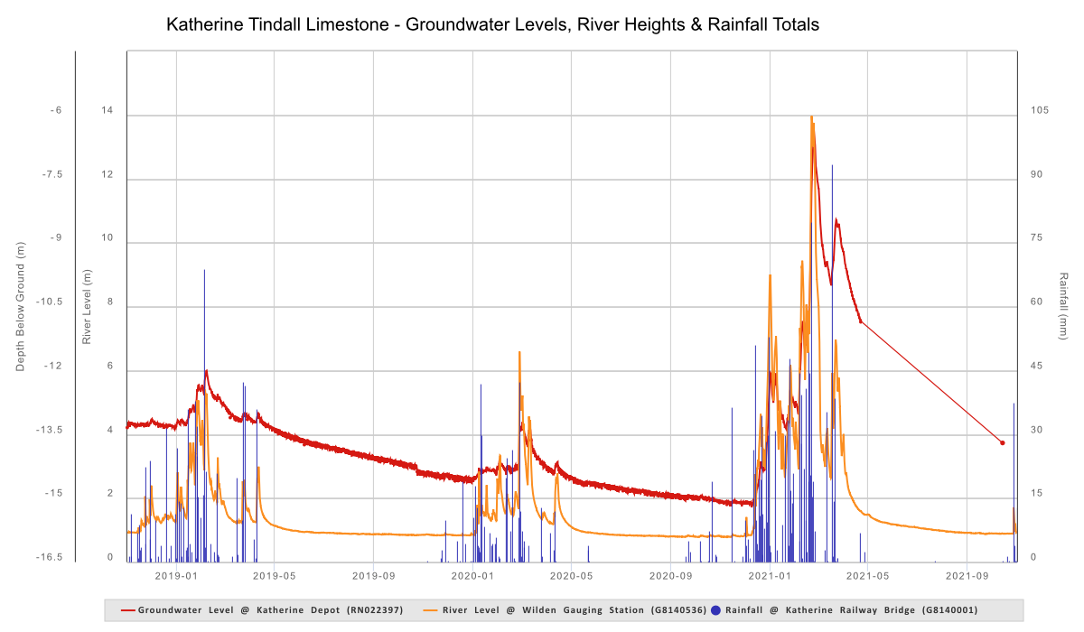
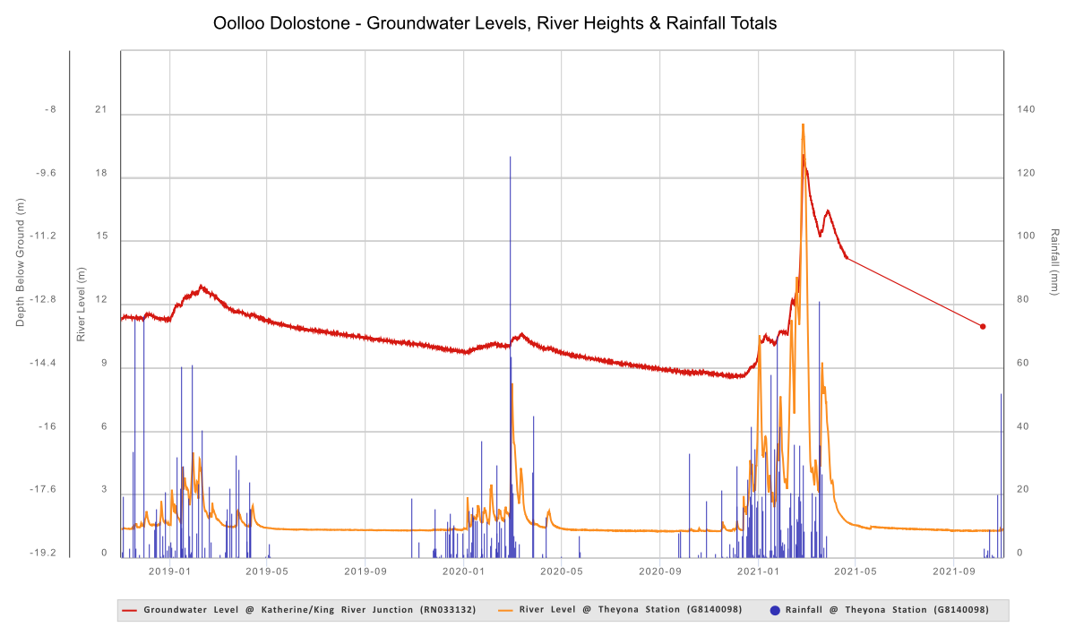
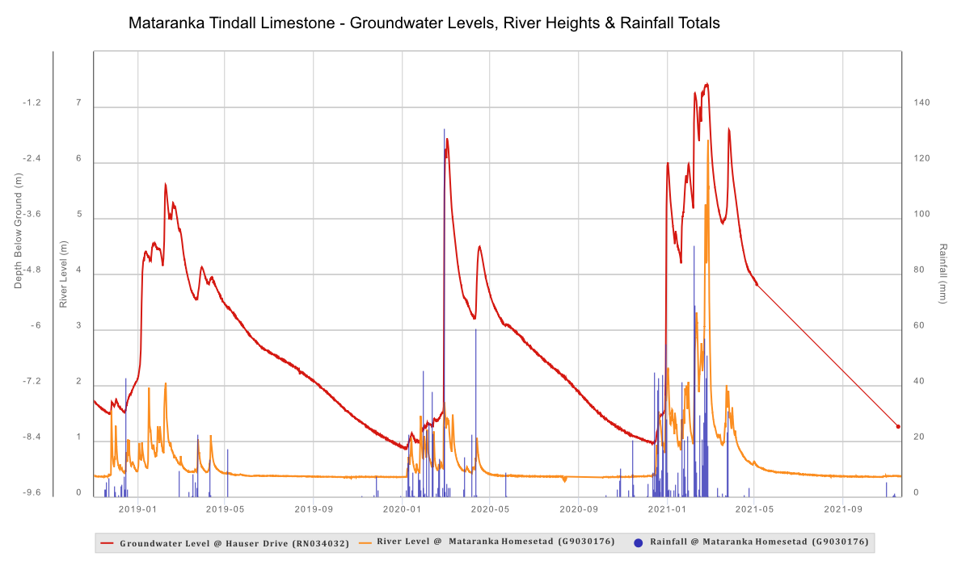

2022 Announced allocation outlook
Modelling of water extraction which considers rainfall (including predicted rainfall for February to April), water extraction and recharge will be undertaken in February 2022 to inform an Early Notice to licence holders in March 2022. Further modelling, if required, using updated climate information, will be undertaken in March 2022 to inform an allocation announcement.
The Controller of Water Resources will provide advice to relevant licence holders of their 2022-23 annual announced allocation before 1 May 2022.
Based on the status of water use in the region, the climate and rainfall outlook and the measured groundwater levels presented in this update it is likely allocations for the 2022-23 water accounting will be 100 per cent for the following water resources:
- Katherine Tindall Limestone
- Oolloo Dolostone
- Mataranka Tindall Limestone
- Tindall Limestone Aquifer (Flora)
- Jinduckin Formation
- Edith River
- Adelaide River
- Katherine River upstream of Tindall Limestone Aquifer Donkey camp weir

More information
Water allocation plans: https://depws.nt.gov.au/water/water-management/water-allocation-plans
Water Licensing Portal: https://denr.nt.gov.au/water/permits-and-licences/water-licensing-portal
Water Data Portal: https://denr.nt.gov.au/water/water-information-systems/water-data-portal
BOM rainfall outlook: http://www.bom.gov.au/climate/outlooks/#/rainfall/median/weekly/0
BOM Climate drivers: http://www.bom.gov.au/climate/enso/

Contact us
If you have any enquiries about this update, please contact Water Resources on 08 8999 4455 or by emailing waterresources.DEPWS@nt.gov.au.

